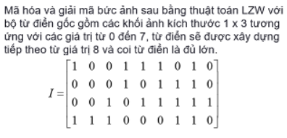

**Mã hoá**

|  |  |  |  |
| --- | --- | --- | --- |
| Input | Output | Codeword | Dictionary |
| 100 | 4 | 8 | 100 - 111 |
| 111 | 7 | 9 | 111 – 010 |
| 010 | 2 | 10 | 010 - 000 |
| 000 | 0 | 11 | 000 - 101 |
| 101 | 5 | 12 | 101 - 110 |
| 110 | 6 | 13 | 110 - 001 |
| 001 | 1 | 14 | 001 - 011 |
| 011 | 3 | 15 | 011 - 111 |
| 111 | 7 | 16 | 111 – 111 |
| 111 | 7 | 17 | 111 - 000 |
| 000 | 0 | 18 | 000 - 110 |
| 110 | 6 |  |  |

Văn bản mã hoá: 4 – 7 – 2 – 0 – 5 – 6 – 1 – 3 – 7 – 7 – 0 - 0

**Giải mã**

|  |  |  |  |
| --- | --- | --- | --- |
| Input | Output | Codeword | Dictionary |
| 4 | 100 |  |  |
| 7 | 111 | 8 | 100 - 111 |
| 2 | 010 | 9 | 111 - 010 |
| 0 | 000 | 10 | 010 - 000 |
| 5 | 101 | 11 | 000 - 101 |
| 6 | 110 | 12 | 101 - 110 |
| 1 | 001 | 13 | 110 - 001 |
| 3 | 011 | 14 | 001 - 011 |
| 7 | 111 | 15 | 011 - 111 |
| 7 | 111 | 16 | 111 - 111 |
| 0 | 000 | 17 | 111 - 000 |
| 6 | 110 | 18 | 000 - 110 |